**Solution 1**

1. Probability Distribution of X: Poisson Distribution.

How it satisfies: Poisson distribution is generally used to model the number of successes per unit area or time (here Cars arrival is the occurrence/success)

> dpois(5,6.7)

[1] 0.1384904

> ppois(5,6.7)

[1] 0.3406494

**Solution 2**

> 1-punif(37,30,40)

[1] 0.3

> punif(32,30,40)

[1] 0.2

> punif(38,30,40) - punif(34,30,40)

[1] 0.4

**Solution 3**

**Solution 4**

> pexp(6,rate = 1/5)

[1] 0.6988058

> pexp(5,rate = 1/5) - pexp(3,rate = 1/5)

[1] 0.1809322

**Solution 5**

> dbinom(25,400,.07)

[1] 0.06867971

> pbinom(24,400,.07)

[1] 0.2511457

> pbinom(25,400,.07) - pbinom(20,400,.07)

[1] 0.2541306

**Solution 6**

> x<-rpois(100,3)

> y<-x^2

> hist(y,main = "Histogram of y (1st part)",col = "blue",xlab = "Y", ylab = "Density")

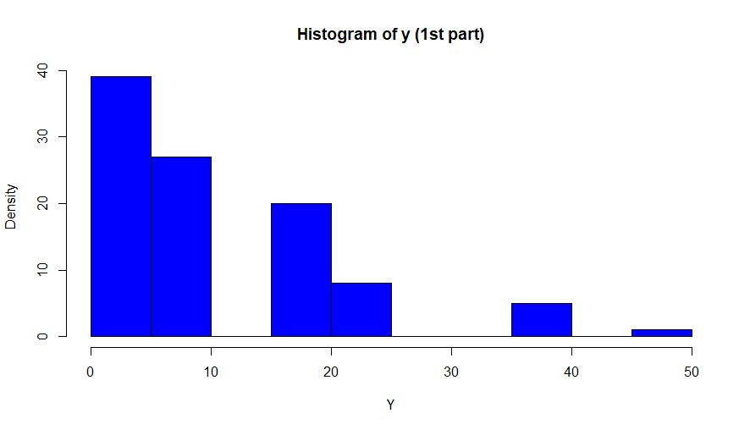

> dt<-data.frame(y_bar=0,sd=0) #Initializing an empty data frame

> for (i in 1:1000) { #looping 1000 times to store y_bar in dt

+ x<-rpois(100,3)

+ y<-x^2

+ y_bar<-mean(y)

+ sd<-sd(y)

+ dt<-rbind(dt,cbind(y_bar,sd))

+ }

> dt<-data.frame(dt[2:1001,])

> hist(dt$y_bar,col = "blue",density = 20, main = "Histogram of y_bar (1st part)")

Histogram below (normally shaped) is generated from random variable X (poisson distributed)

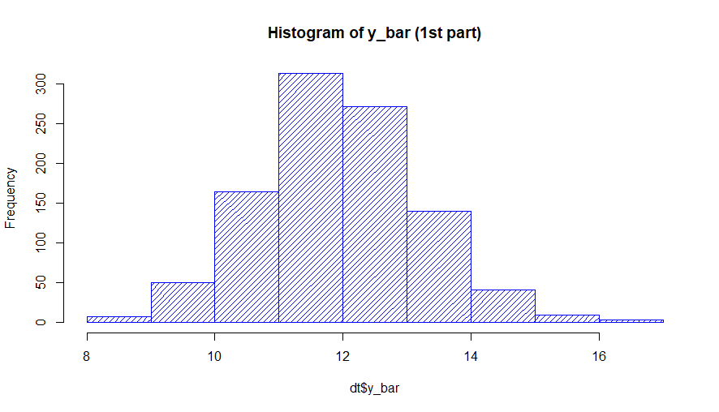

> u_bar<-mean(dt$y_bar)

> dt$z<-with(dt, (dt$y_bar - u_bar)/(dt$sd/10))

> hist(dt$z,density = 20,col = "blue", main = "Histogram of Z & fitted normal curve (1st part)",xlim = c(-4,3),ylim = c(0,0.45),probability = TRUE,xlab = "Z",ylab = "Density")

> par(new = TRUE)

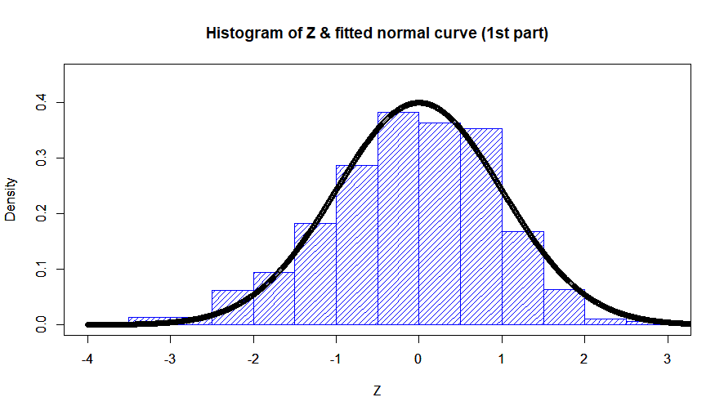

> x<-rexp(100,1/3)

> y<-x^2

> hist(y,main = "Histogram of Y (2nd part)", col = "red",xlab = "Y", ylab = "Density")

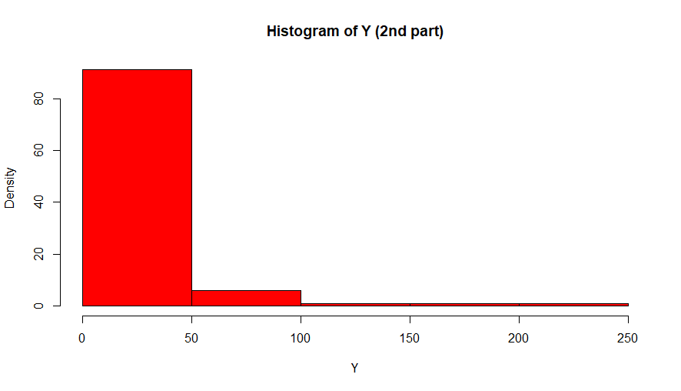

> dt<-data.frame(y_bar=0,sd=0) #Initializing an empty data frame

> for (i in 1:1000) { #looping 1000 times to store y_bar in dt

+ x<-rexp(100,1/3)

+ y<-x^2

+ y_bar<-mean(y)

+ sd<-sd(y)

+ dt<-rbind(dt,cbind(y_bar,sd))

+ }

> dt<-data.frame(dt[2:1001,])

> hist(dt$y_bar,col = "red",density = 20, main = "Histogram of y_bar (2nd part)")

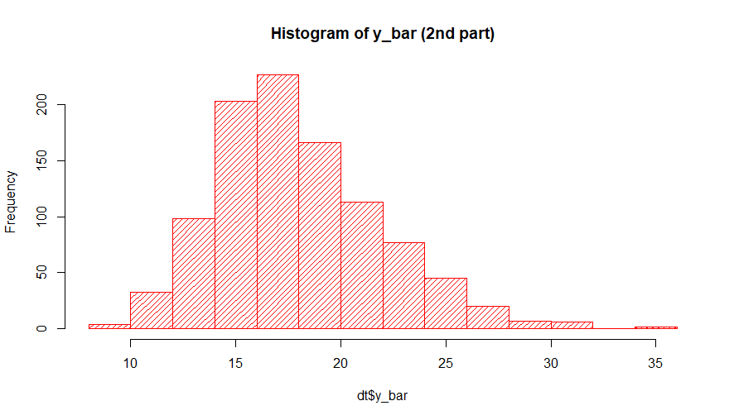

> u_bar<-mean(dt$y_bar)

> dt$z<-with(dt, (dt$y_bar - u_bar)/(dt$sd/10))

> hist(dt$z,density = 20,col = "red", main = "Histogram of Z & fitted normal curve (2nd part)",xlim = c(-4,3),ylim = c(0,0.45),probability = TRUE,xlab = "Z",ylab = "Density")

> par(new = TRUE)

> plot(seq(-4,4,by = 0.005),dnorm(seq(-4,4,by = 0.005)),xlim = c(-4,3),ylim = c(0,0.45),xlab = "Z",ylab = "Density")

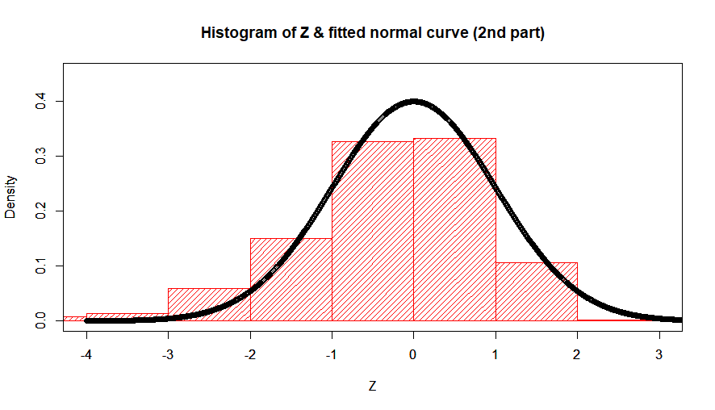

**Comment:** Normal curve fit very good on both the distribution in part 1 { poison: (1), (2) ,(3) } & part 2 { (4) - exponential}. It implies that whatever was our X (exponential or poison), the distribution of the mean of their samples is normally distributed.